How to Avoid Charges at Move-Out 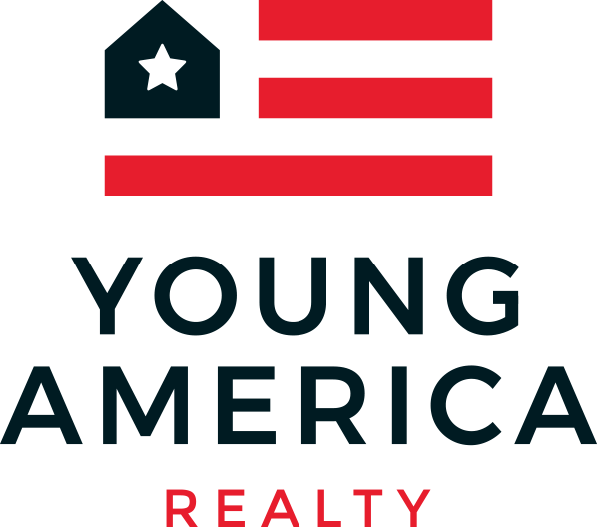

Dear Current Residents:
Thank you for choosing Young America Realty as your student housing provider. We have appreciated the opportunity to serve you. If you are graduating, let us congratulate you on this momentous opportunity.
Unless your lease states otherwise, you must vacate your apartment by Saturday May 11th, 2019 at 12 p.m. (noon). As we enter the final few weeks of school, Young America would like to take the opportunity to thank you for choosing us as your housing provider. Please use this letter as a guideline to assist with your move out procedures. We apologize if this letter seems heavy handed, but we want to make sure that everyone understands the importance of leaving the unit on time and leaving the unit in good standing condition. We thank you for choosing Young America, and we hope that you have enjoyed your experience.
We also would like to remind you of your responsibility to leave your unit in a clean and move-in ready condition prior to vacating the premises.
Please keep in mind that if you have charges that exceed your security deposit, you are still responsible for paying those charges. Failure to pay those charges will result in your account being turned over to a collections agency.
Please pay careful attention to the following items:
DAMAGE:
- EXCESSIVE DAMAGE TO YOUR UNIT WILL BE VIEWED AS CRIMINAL DAMAGE TO PROPERTY. LAW ENFORCEMENT WILL GET INVOLVED, AND CHARGES ABOVE $300 WILL BE TREATED AS A FELONY, BY LAW. IF YOU CHOOSE TO DAMAGE OR VANDALIZE YOUR APARTMENT YOU WILL HAVE A FELONY CRIMINAL RECORD FOLLOW YOU THROUGH LIFE.
- Damage to the apartment will be compared against the move-in inspection that you were required to complete upon to move-in last year. If you did not complete this inspection, then all damage will be charged to your account.
- Damage to carpet (burns, stains, bleach, rips, cuts, etc) will be charged to your account.
- Damage to carpet and/or vinyl will be charged to your account.
- Damage to televisions (repair or replace) will be charged to your account.
- Drywall / paint repairs (including repainting tenant paint projects) will be charged to your account.
- Missing television remotes will be charged to your account.
- Make sure your air conditioning is turned OFF, and ensure all your windows and doors are locked.
- Do not unplug or turn off the refrigerator or turn off any breakers! Refrigerators that are unplugged will rot and the entire fridge will likely need to be thrown away. The cost of the refrigerator will be charged to your account
CLEANING:
- LIVING ROOM: Clean walls and wood trim. Vacuum carpet and clean floor. Clean windows & sills. Clean blinds. Clean ceiling fans. Clean Furniture Couch/Chair. Smoke detectors must not be missing or removed. Remove all trash
- KITCHEN: Clean walls and wood trim. Clean countertops / tile. Clean shelves / drawers / cabinets. Clean burners / oven / broiler. Clean floor and mop. Clean refrigerator. Clean Microwave. Smoke detectors must not be missing or removed. Remove all trash.
- EACH BEDROOM: Clean walls and wood trim. Vacuum and clean floors. Clean windows & sills. Clean light fixtures and heater. Leave beds assembled and in place. Clean Blinds. Clean Furniture. Clean Desks/Closets out. Clean/Vacuum carpet. Smoke detectors must not be missing or removed. Remove all trash.
- Please remember, for those residents who took the “Early Move-in” option last year, you are still responsible for leaving your apartment in a clean and move-in ready condition. Regardless of the cleanliness of your apartment upon Early Move-in, you must leave your apartment clean and move-in ready.
- Any cleaning required prior to the next resident taking occupancy will be charged to your account.

HOLDOVER TENANCY:
- Your lease provides for $1,000 per day fee for failure to move out by the lease end date. Unless your lease states otherwise, you must vacate your apartment by Saturday May 11th, 2019 at NOON. The $1,000 per day fee begins promptly at noon.

KEYS:
- If you have a lock on your bedroom door (which either came with the apartment, or one you specifically requested from our maintenance department), you must leave the key in the knob/lever upon move out. If the key is not in the door knob/lever, your account will be charged.
- If you have a lock on your bedroom door that was not authorized by Young America, we will remove the lock and your account will be charged.
- All other keys, including apartment keys, mailbox keys, security door keys, elevator keys, laundry room keys, and key fobs MUST be returned to our office. A Key Return Form must be completed in your name with a forwarding address or your account will be charged $25 per key and $100 per key fob not returned.

If you will remain in the apartment for another year, Young America will still inspect the property for damage to clearly delineate under which lease any damages occurred. Residents staying in the apartment for another year do not need to move out, or return keys to the YA office.
Thank you for choosing Young America Realty as your housing provider. We appreciate your business, and hope your college living experience was great.

Regards,
Young America Management

